**Project 1**

**Understanding of the website**

This website is about my portfolio as a Website Developer. Our website has a **homepage** with Download My CV option from where you can download my CV and in addition we have nine other modules in right side of the home pages. This website is dynamic. In bottom right side we have mentioned that “All right reserved by me” which indicating that the copyright holder reserves, or holds for its own use.

From homepage we have redirection to nine major links, the these links are nothing but nine main modules that we will implement in our website. List of all the modules is below :

1. About Me
2. Skills
3. Experience
4. portfolio
5. Blog
6. Hire Me
7. Contact Us
8. Login In
9. Sign Up
10. References

We will be discussing each one of these one by one and some of their major functions.

1. **About Me:** This page contains information about myself, Such as name, phone-number, Address, email, Date of Birth, Nationality and my Social Profiles. This page also includes introduction and a short description about my skills, work of experience and area of interest. At bottom left side of the page there is a link arrow and clicking on that we can go back to homepage according to our wish.
2. **Skills:** In this page I have mentioned three types of skills and how much percent of knowledge I have. These skills are Marketable skills, Transferable skills, language skills and knowledge. The database stores my information such as skill_name, skill_type, percentage in the **skills**  table and language_Name and percentage in the **Language** table.

1. **Experience :** This page contain information about my position, Company name and how much year of experience I have in particular fields within date of year This information is stored in Experience table.
2. **Portfolio:** After Login in, user is able to see my portfolio in more detail with portfolio type and description. All Portfolio details are stored in **Portfolio** table. In Portfolio site there are five types such as All, Websites, Applications, Design, Photography. On clicking on each tab User can see my work in that respective portfolio type. In some case if User does not want to filter then they can see **All** my work under **All tab**.
3. **Blog:** in this page we will have a blog forum which we will be implementing in project phase3. It will have different posts created by us. The blog will have major information and comment forums for everyone to discuss and get knowledge, such as advances in application development, new trends in web pages, etc. Users coming to our website and opening a blog will allow them to read comments posted by other users and even write their point of view and they can share their knowledge by replying to any posts. They will need to enter their name, subject and the reply message in order to add comment on our blog.
4. **Hire Me:** In this page user reviews all the designs available, with their prices and list of other features, which we can provide. The user selects a design and click the **Contact Us** button. This will navigate to Contact Us page, where the user gives vital details such as full name , Email address, Phone number and the query/message they wanted to ask and click the Send Now message button. The database stores client information and messages in the **contact_req_table**  in order to give response.
5. **Contact Us:** If users have any queries regarding the application they can ask those queries using the **Contact Us** page. In order to ask a query users have to provide their full name , Email address, Phone number and the query/message they wanted to ask and click the Send Now button. The database stores Client information and messages in the **contact_req_table**  in order to give response.
6. **Login:** This page is called “**Login Page**”. This page contains two field to enter User name and password. Any users who have already signed up can simply enter the two details and are able to view my Portfolio in further detail and they can also hire me for their design request.
7. **Sign Up :** Users who want to sign up can enter details like first name, last name, user, email and password. After signing in, user is navigated to a dashboard which shows Login page. All Sign Up details are stored in **User_Datails** table.
8. **References:** This page contains information about my references which is provided by my other clients or employer. User coming to our website and opening it will allow them to read references posted by other users and can even write reference about myself. They will need to enter their name, position, picture and comment message in order to add references. All the information is stored in **Ref_table.**

**ER Diagram**

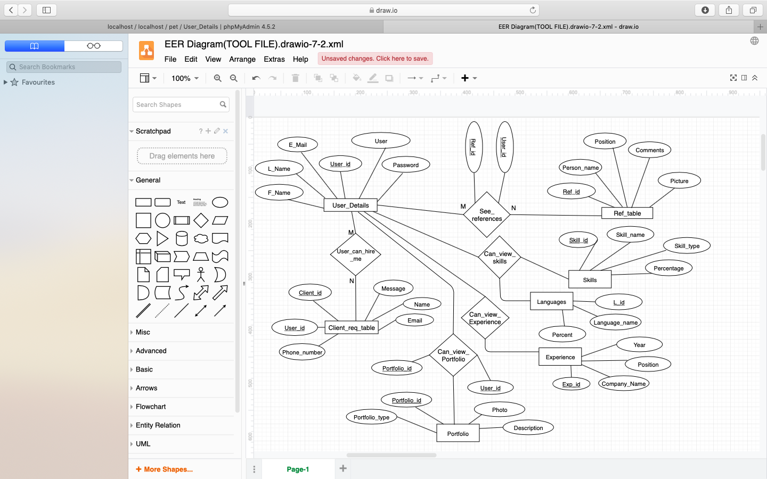

**DB Schema**

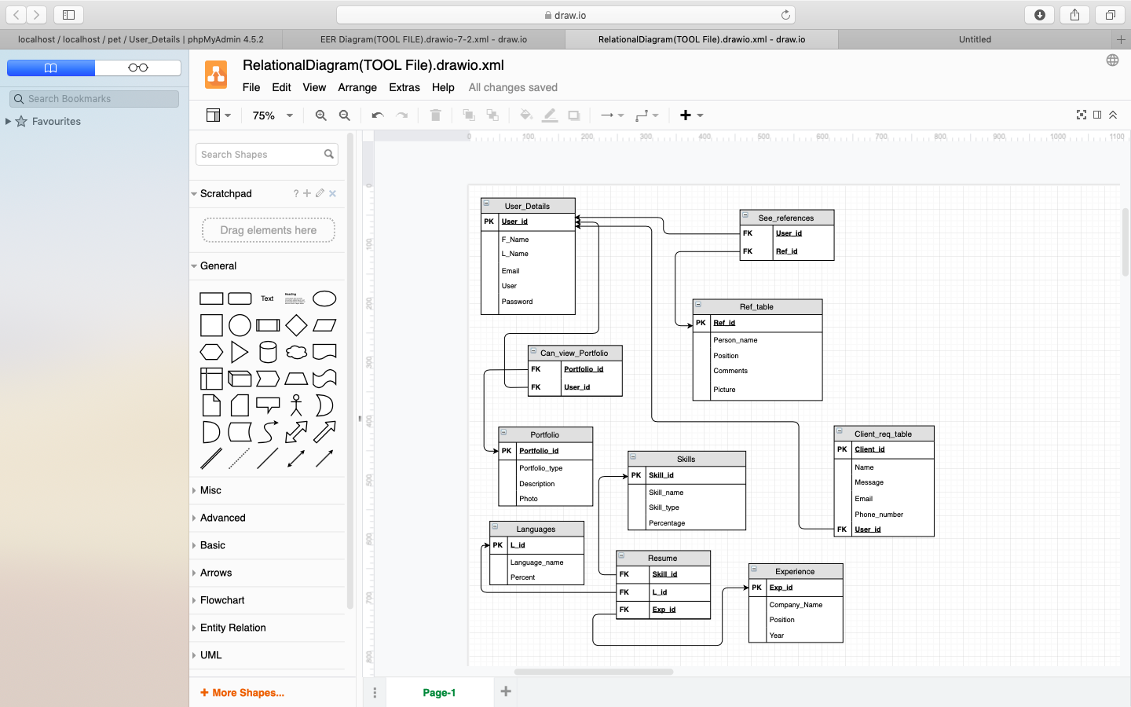

**Screenshots of Database**

**Screenshot of DB Definition**

Database: (pet -10 tables)

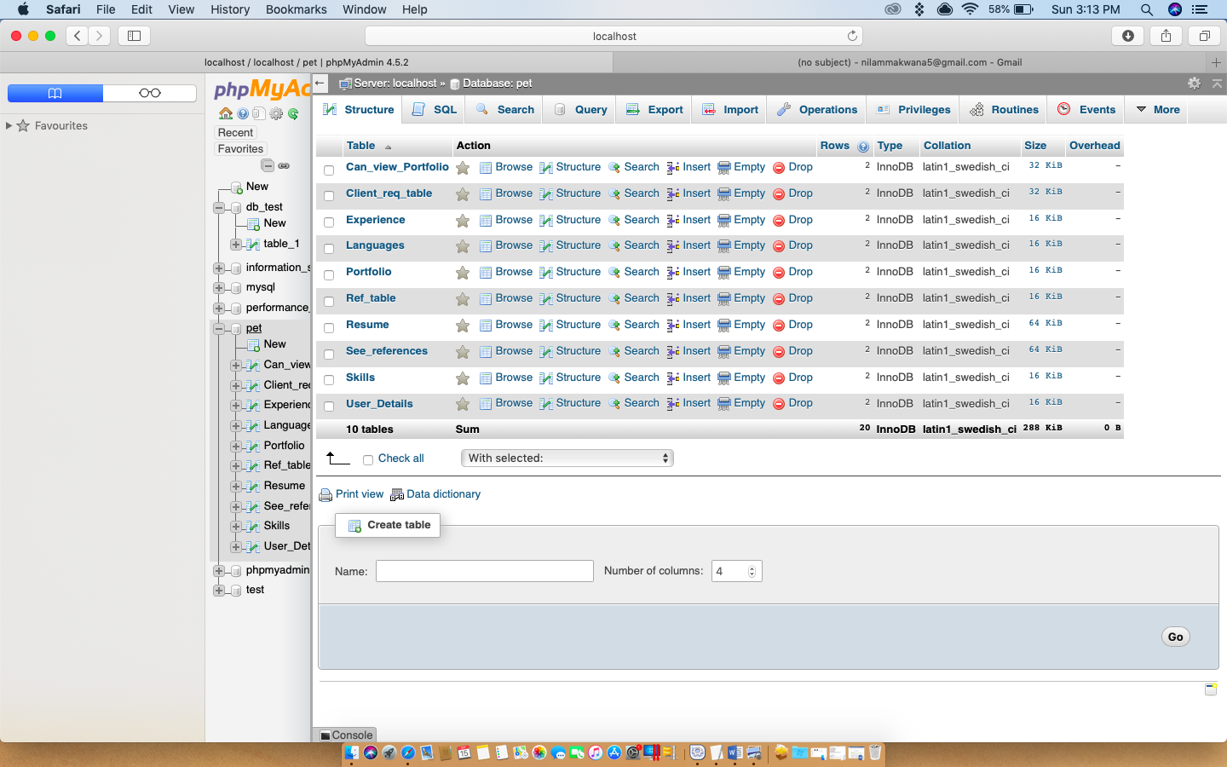

User_Details:

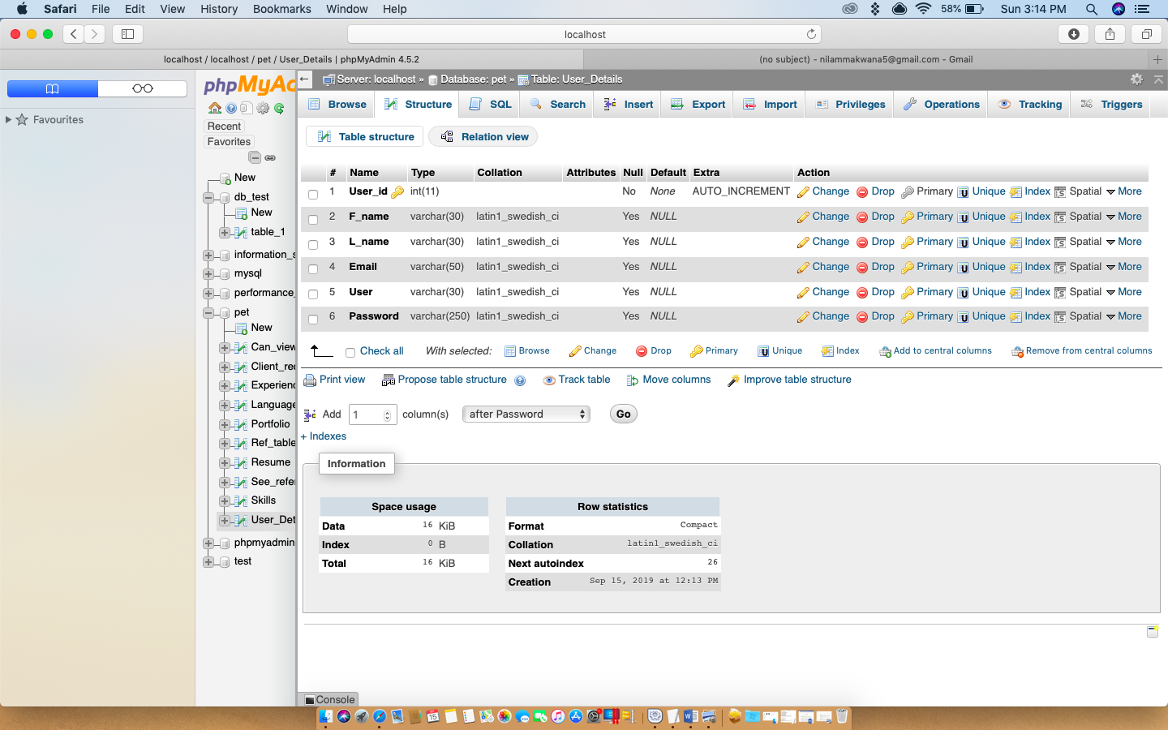

Ref_table:

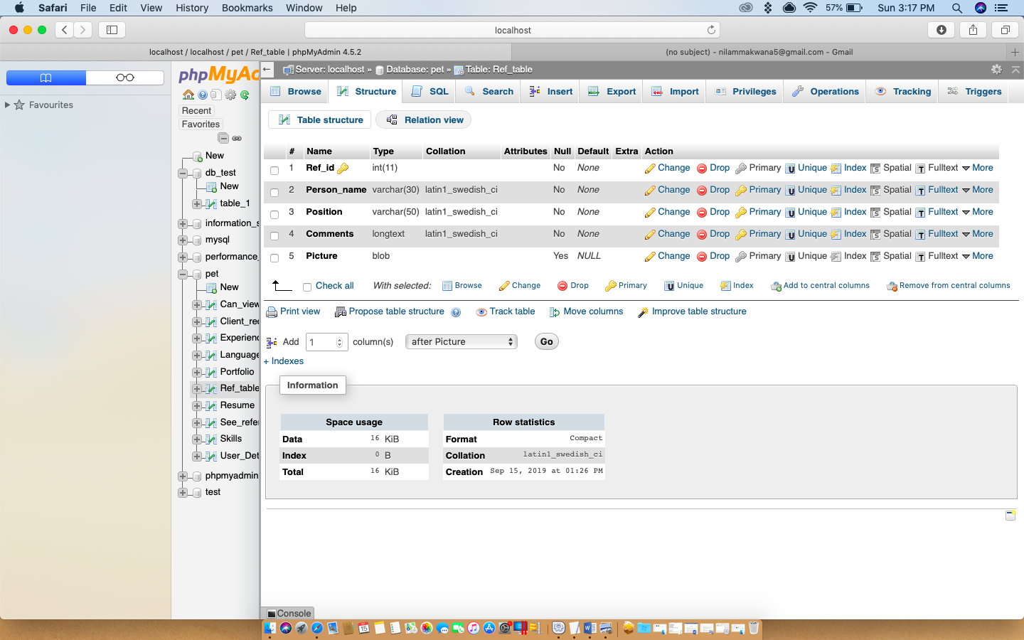

See_references:

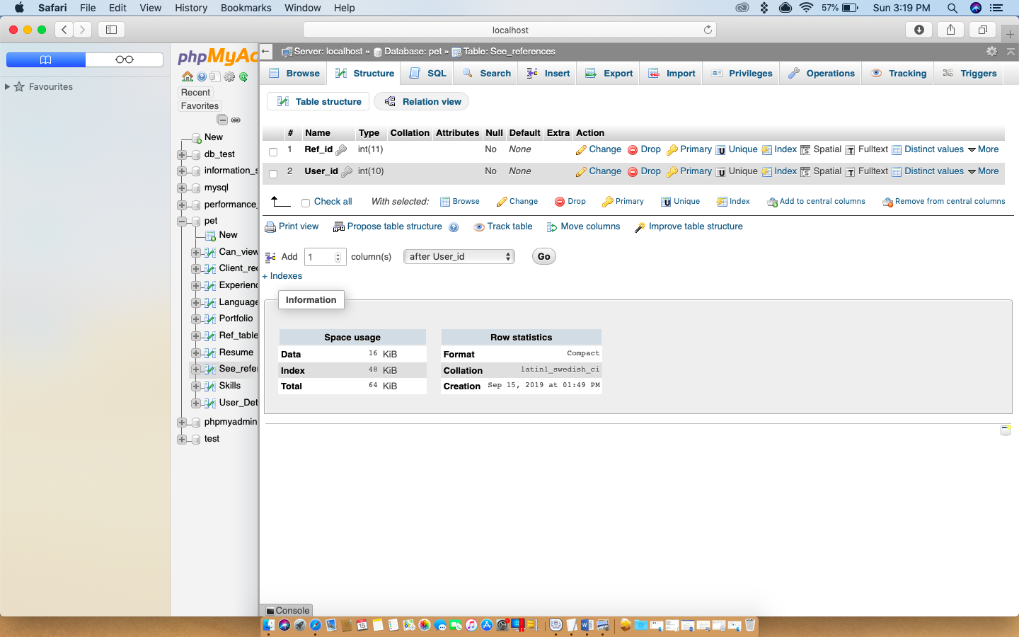

Client_req_table:

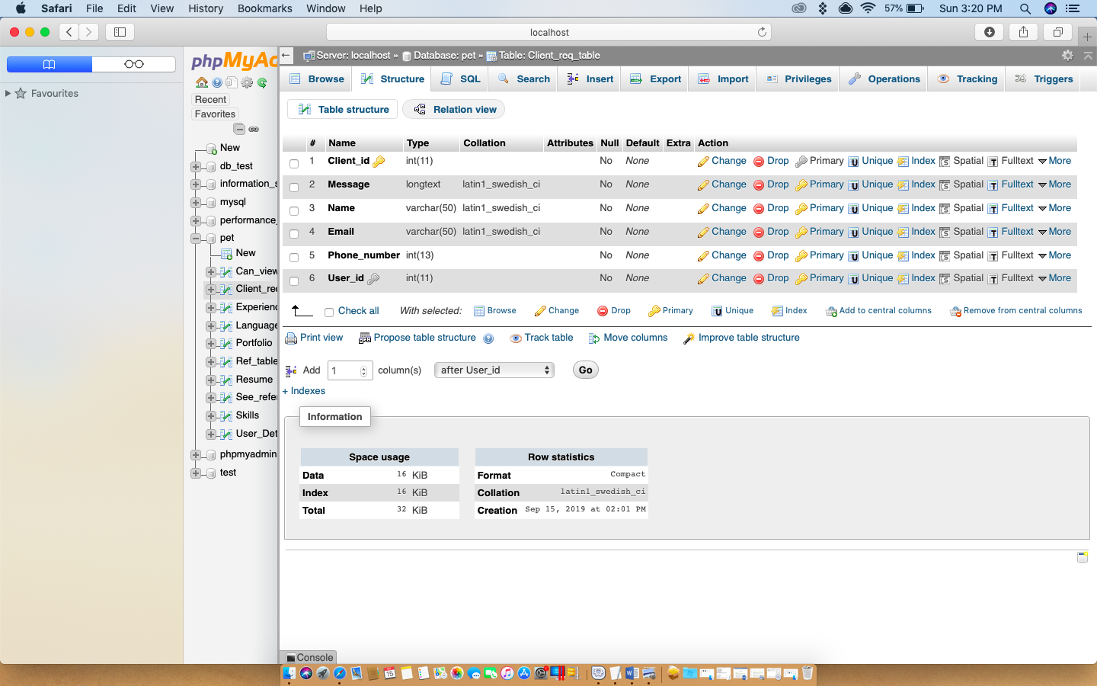

Skills:

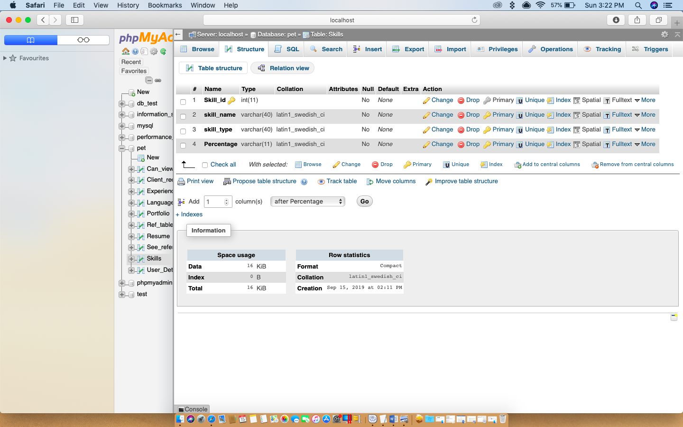

Languages:

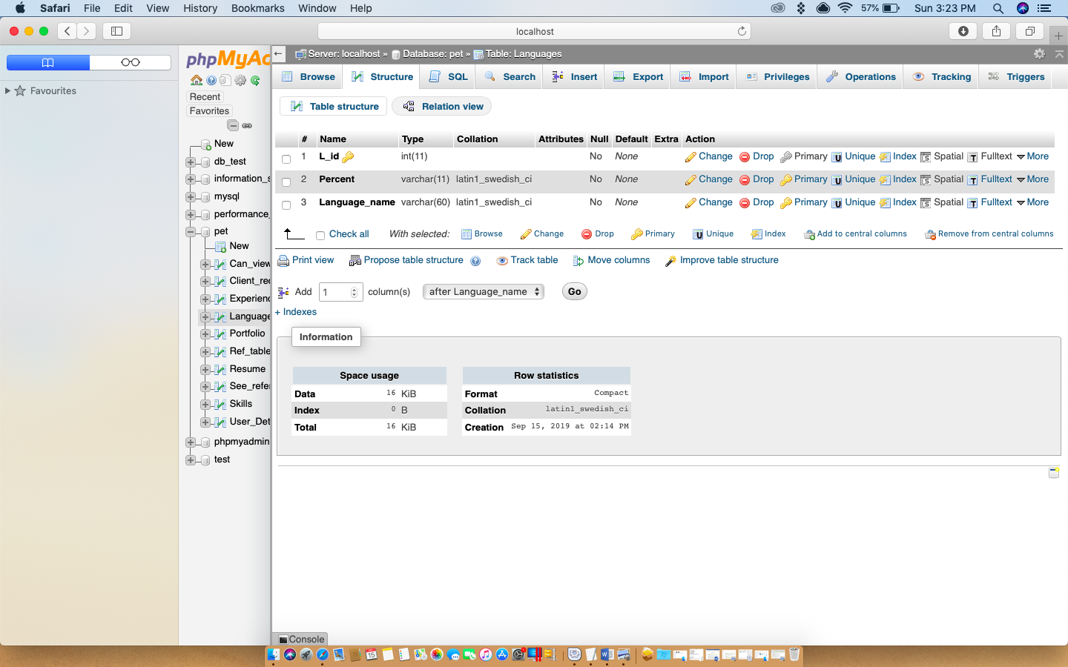

Experience:

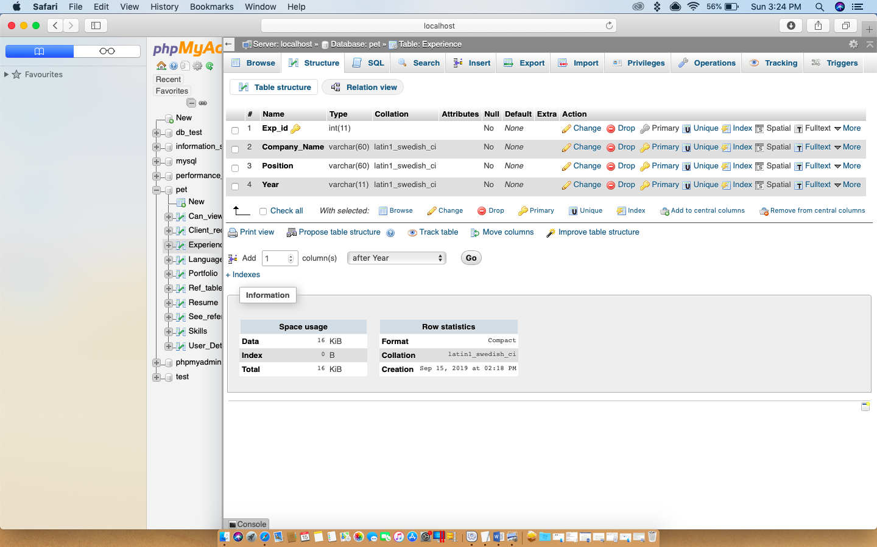

Portfolio:

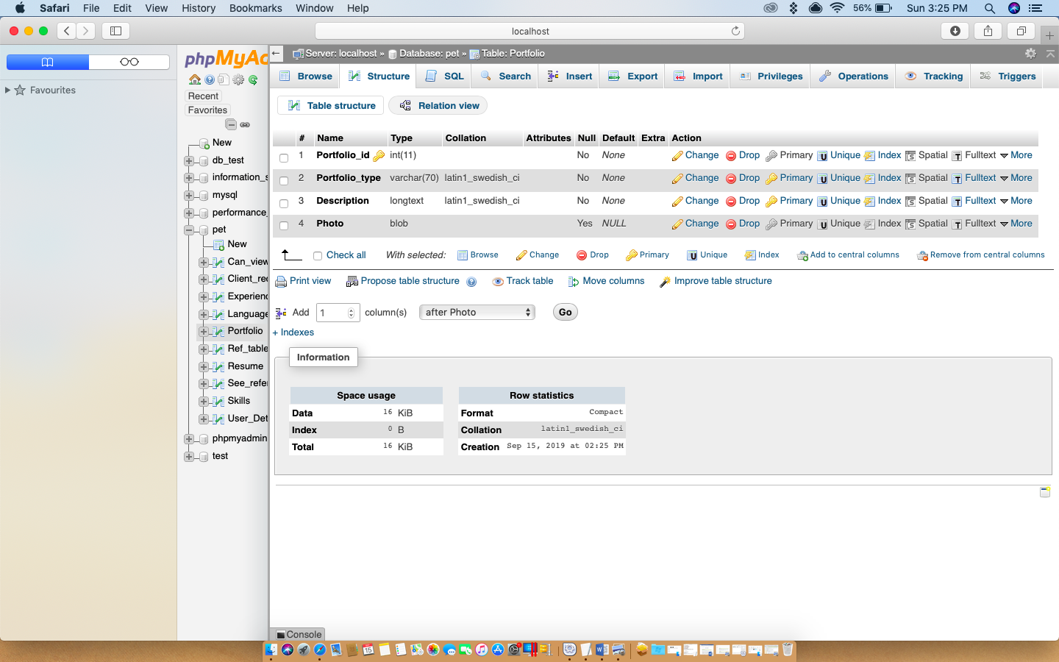

Can_view_Portfolio:

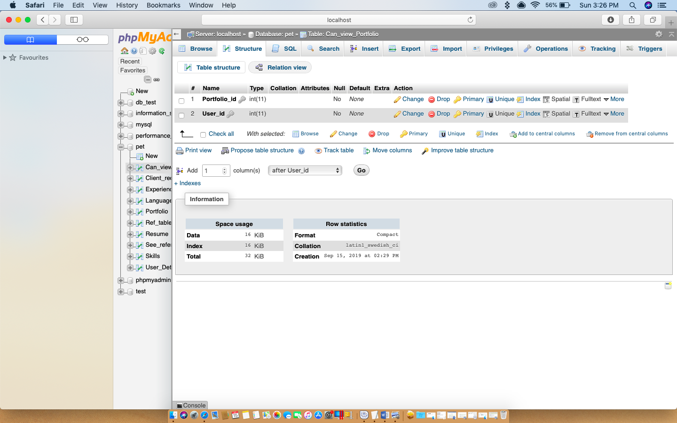

Resume:

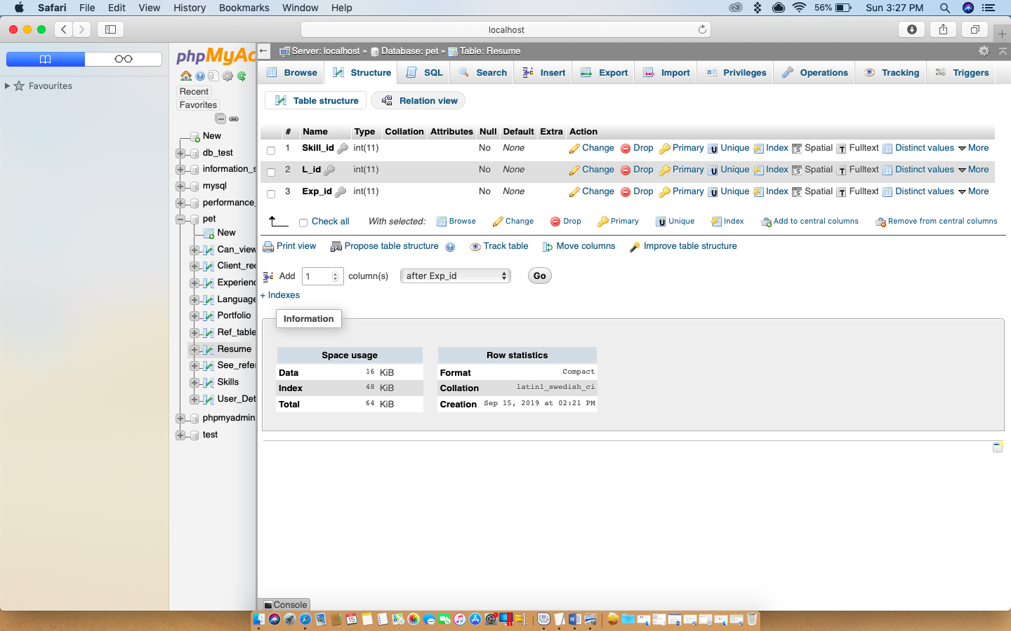

**Screenshot of Populated DB**

SELECT * FROM User_Details;

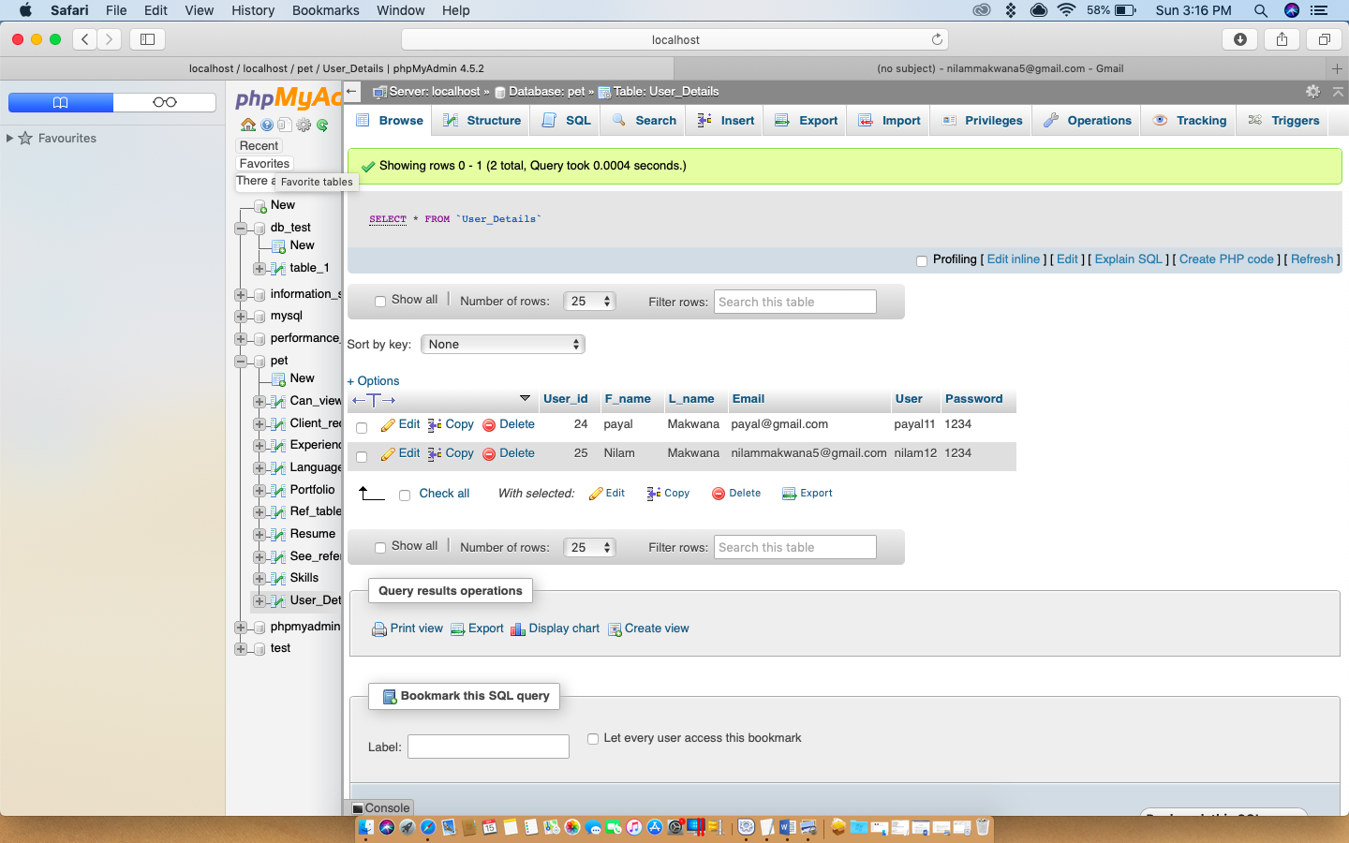

SELECT * FROM Ref_table;

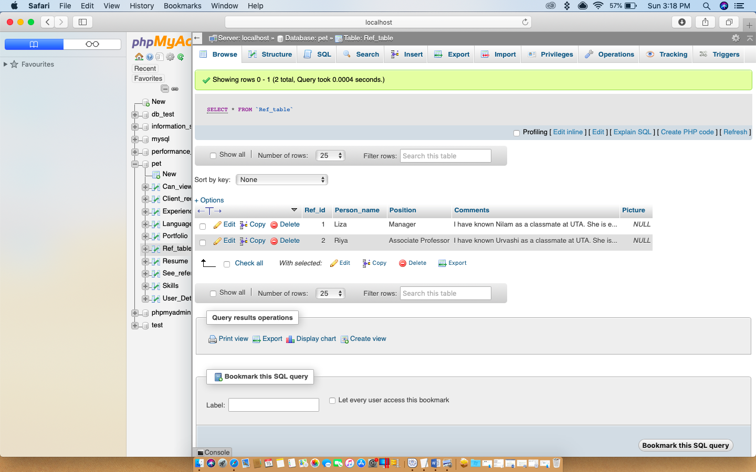

SELECT * FROM See_references;

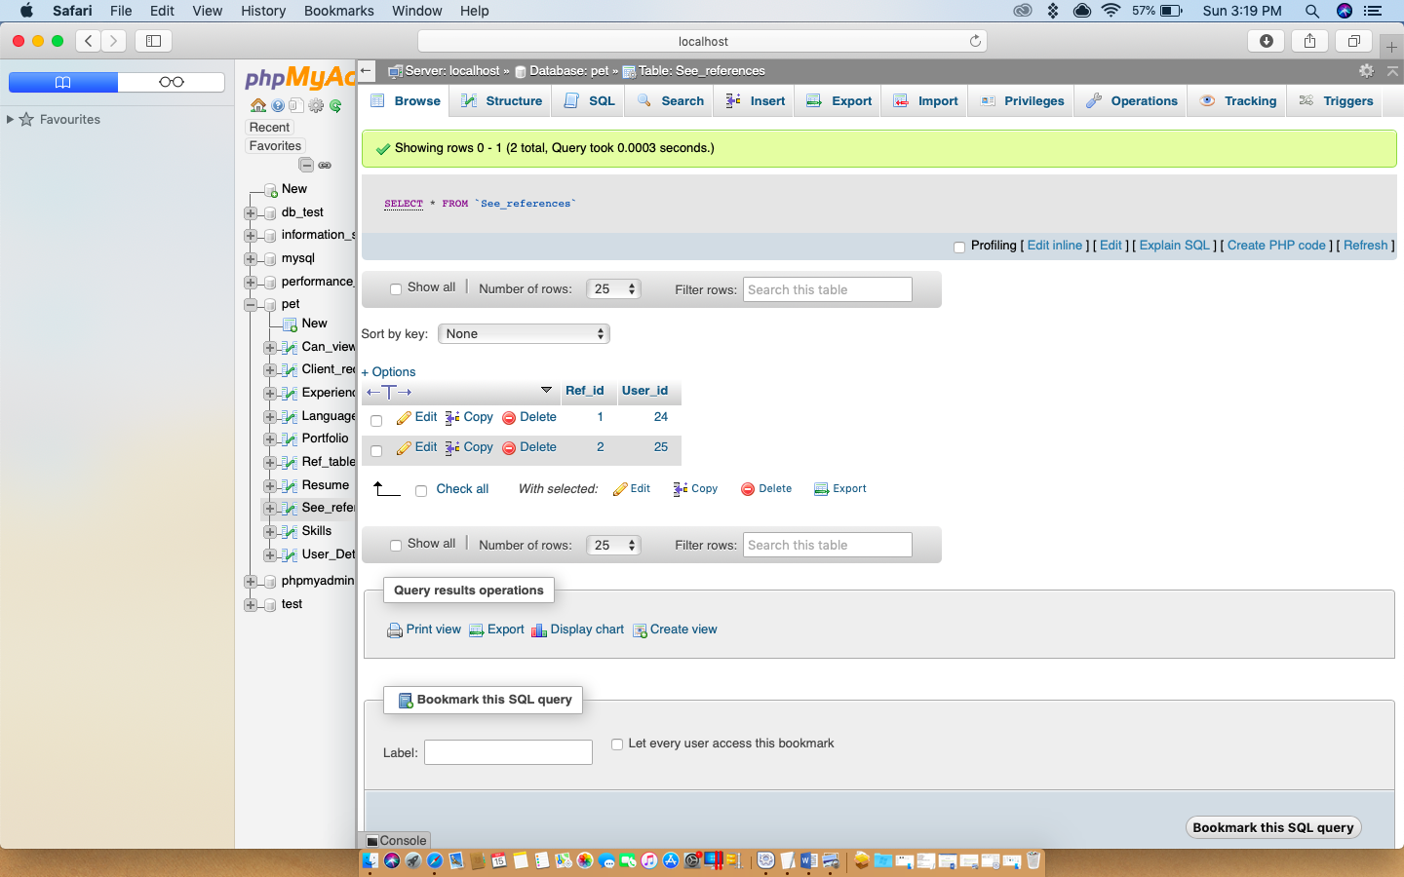

SELECT * FROM Client_req_table;

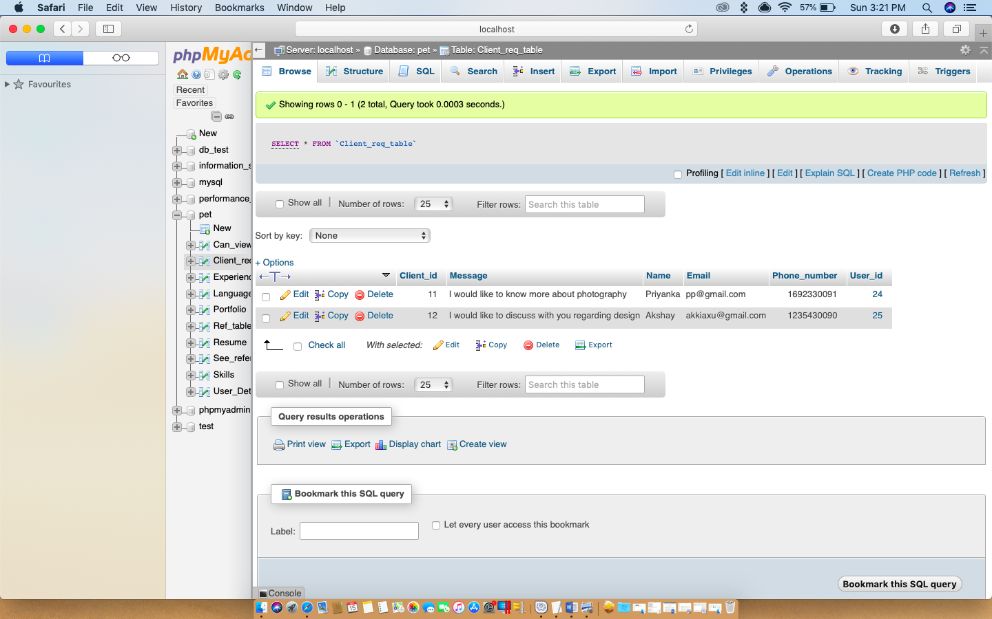

SELECT * FROM Skills;

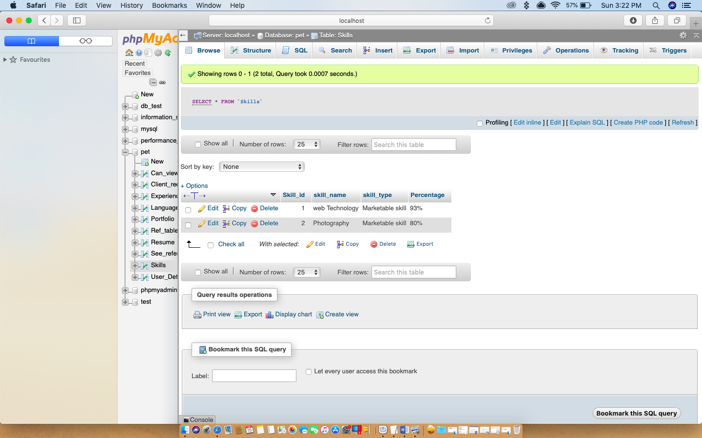

SELECT * FROM Languages;

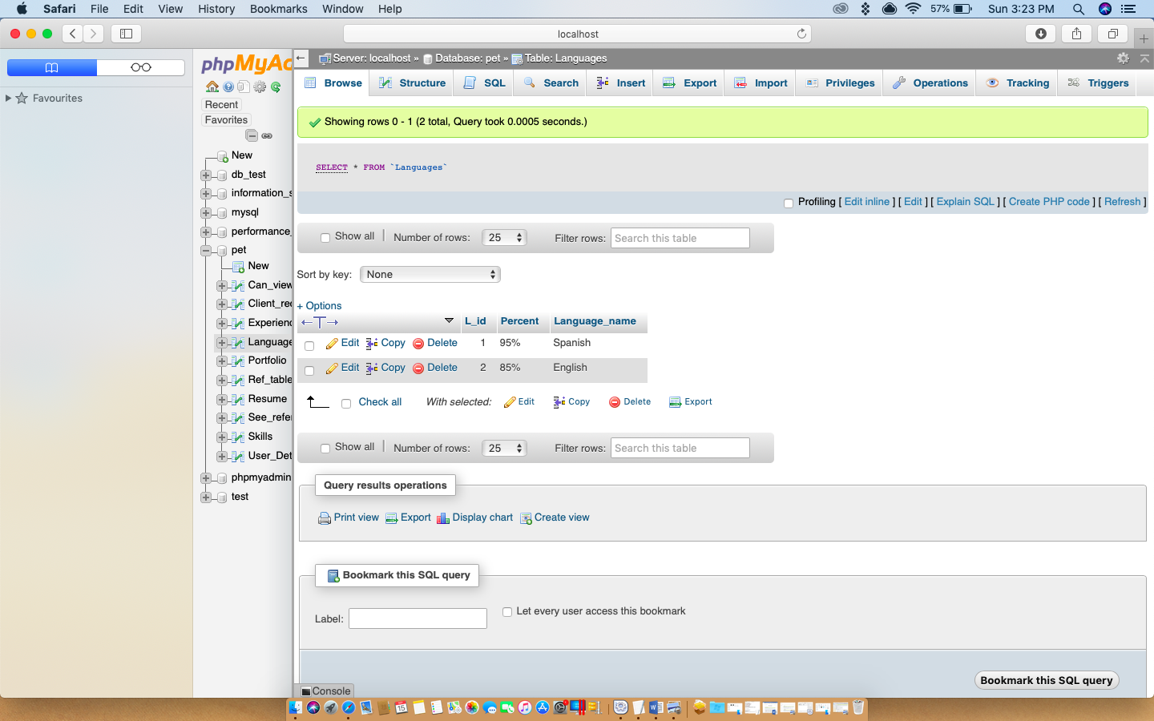

SELECT * FROM Experience;

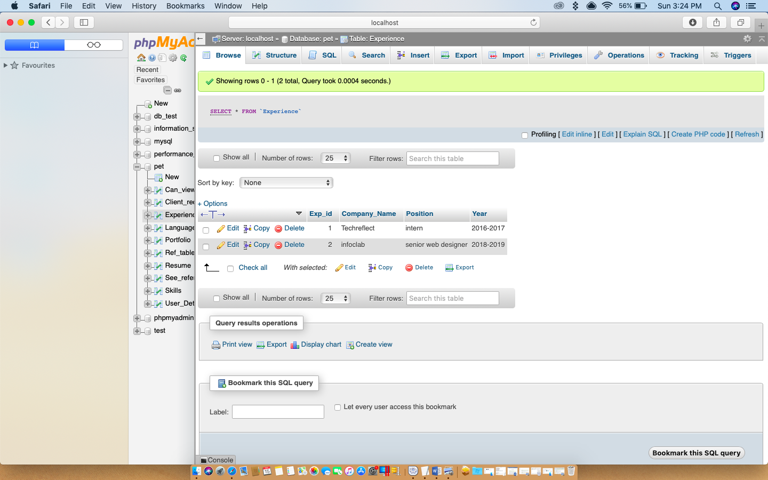

SELECT * FROM Portfolio;

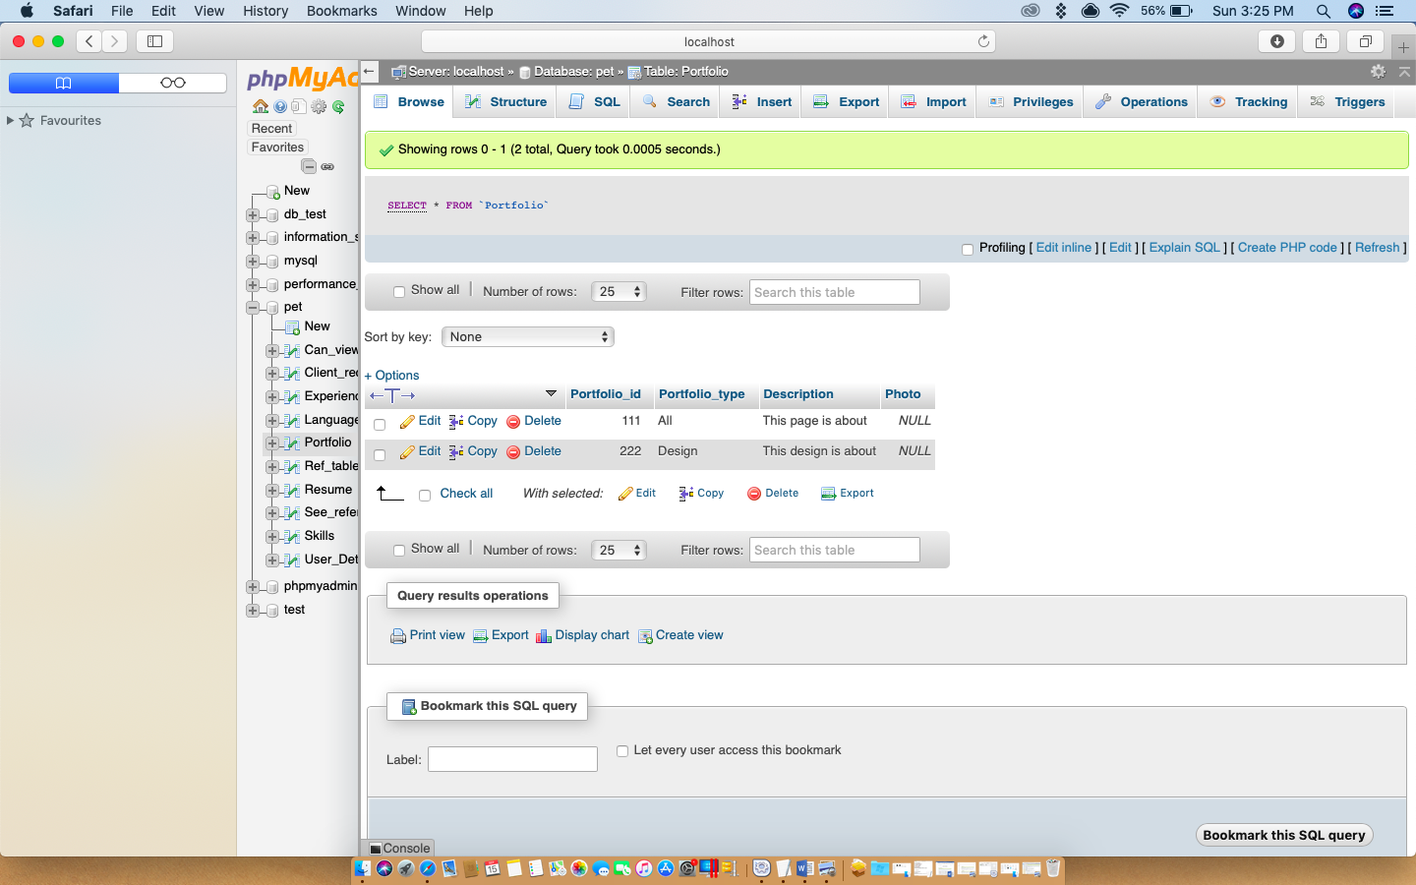

SELECT * FROM Can_view_Portfolio;

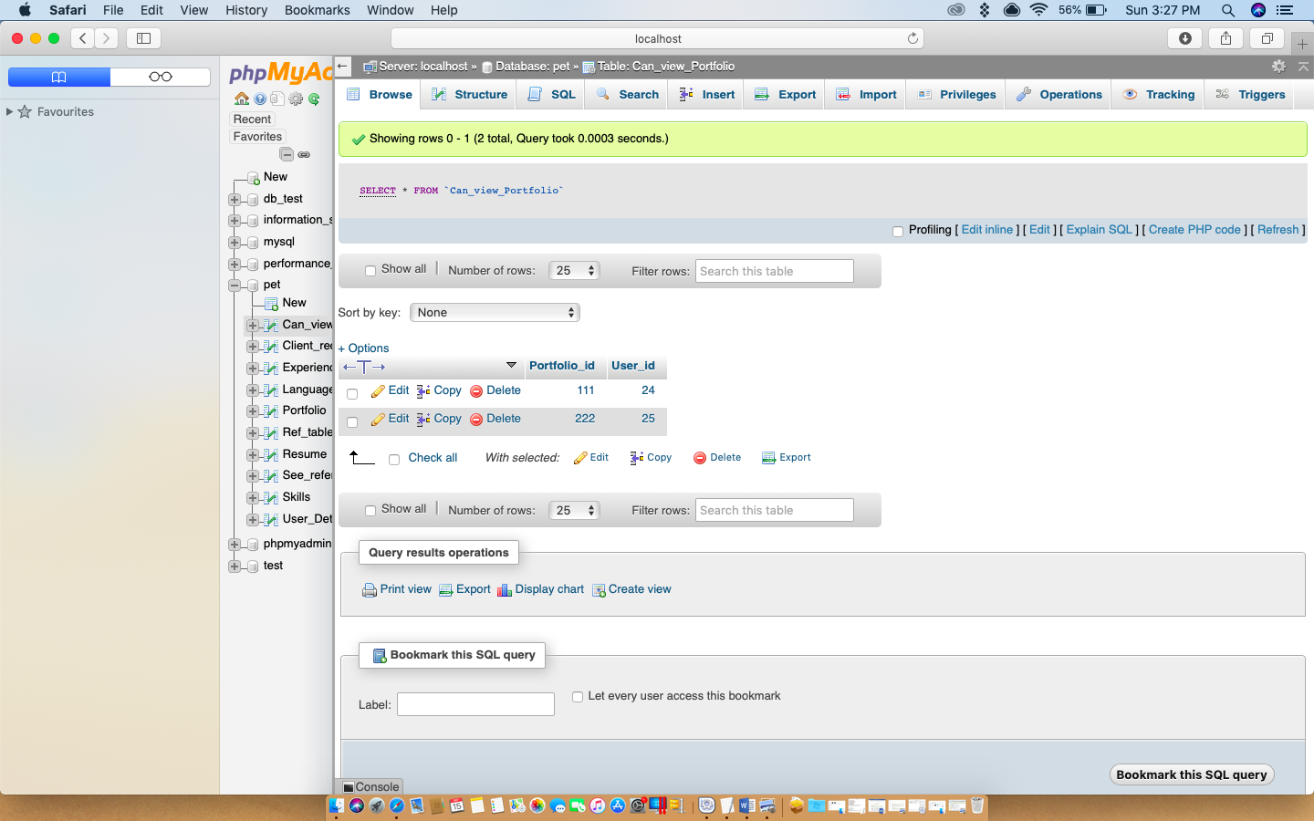

SELECT * FROM Resume;

